Assignment 2 CNNs
Two Layer
Default run with no augmentation or normalization using Adam optimization and scheduler
Does okay around 43% train and Val
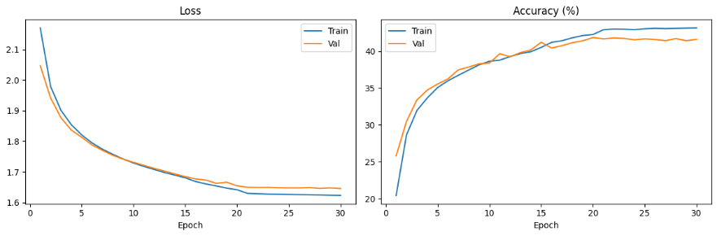
Misclassified images
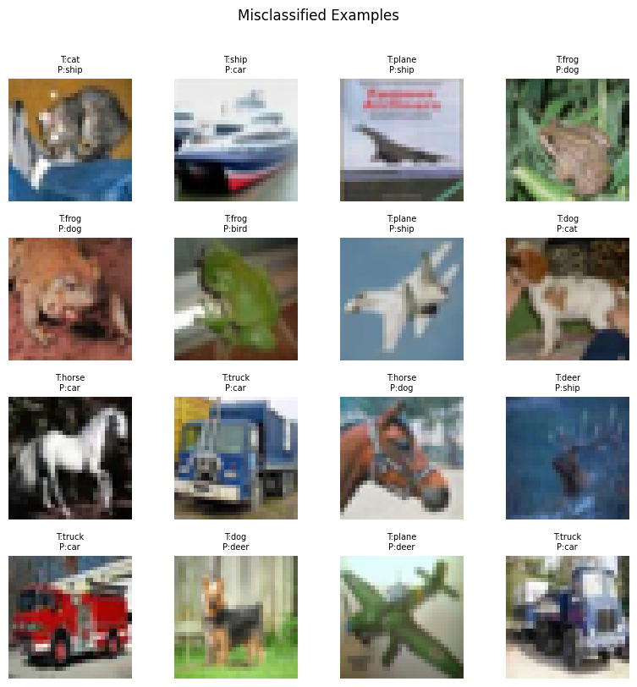

Default With augmentation and no normalization using Adam optimization and scheduler
plateaued early around 20 epochs at 36% so I ended early
Default with both augmentation and normalization
Did about as well as without both
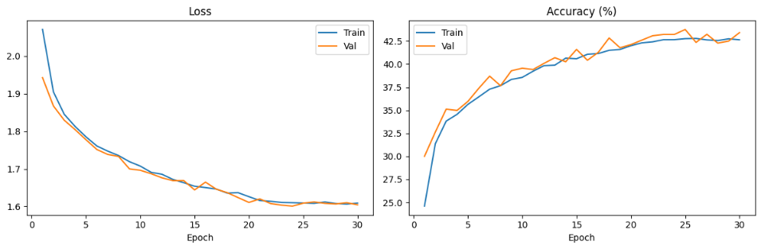
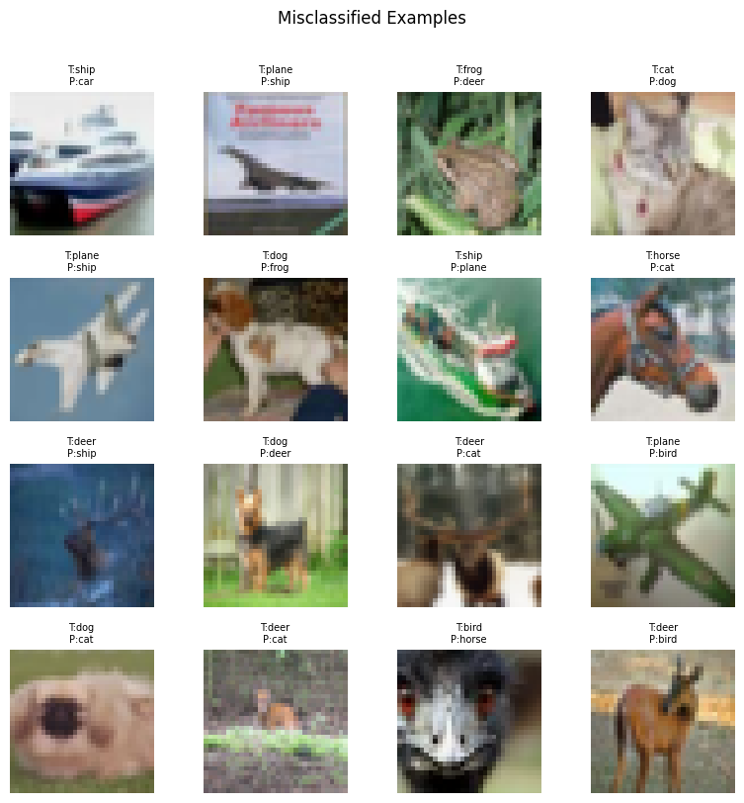
Added use_bn = true and doubled number of channels using Adam optimization and scheduler
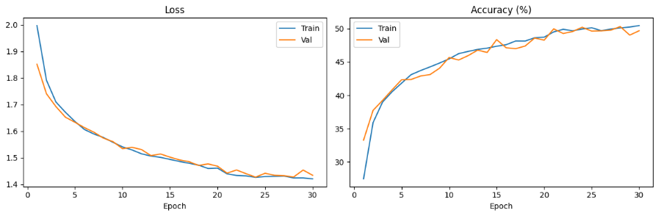
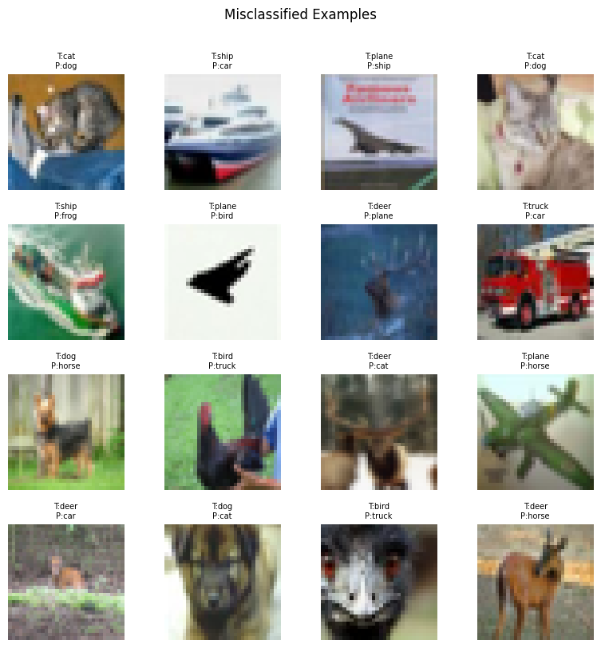
Kept above params and changed to sgd with momentum
Performed worse then before
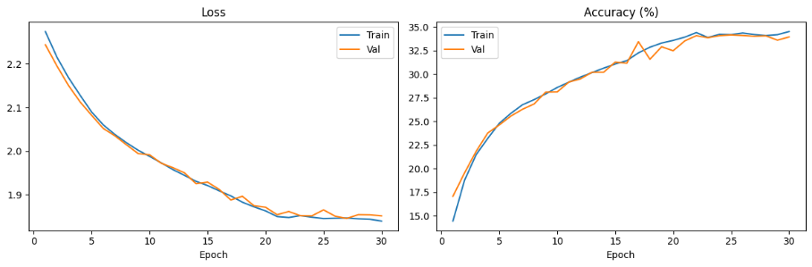
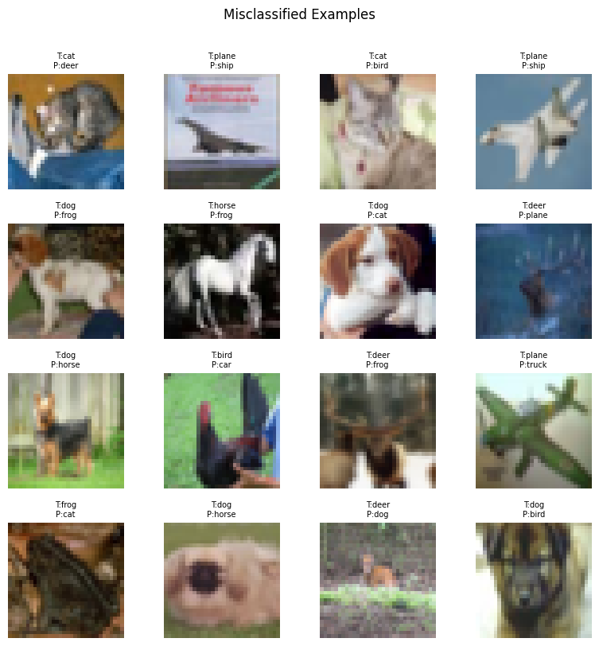

Increasing learning rate to 1e^-1 and number of epochs to 50 resulted to accuracies of around 50% with no overfitting
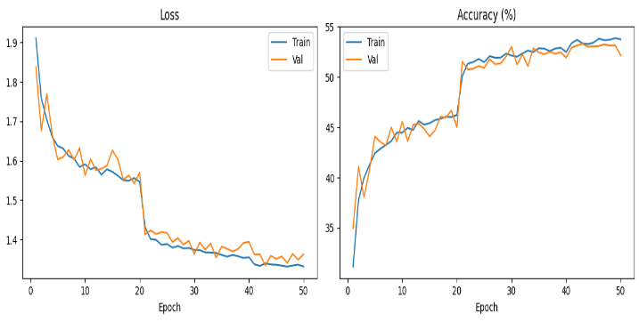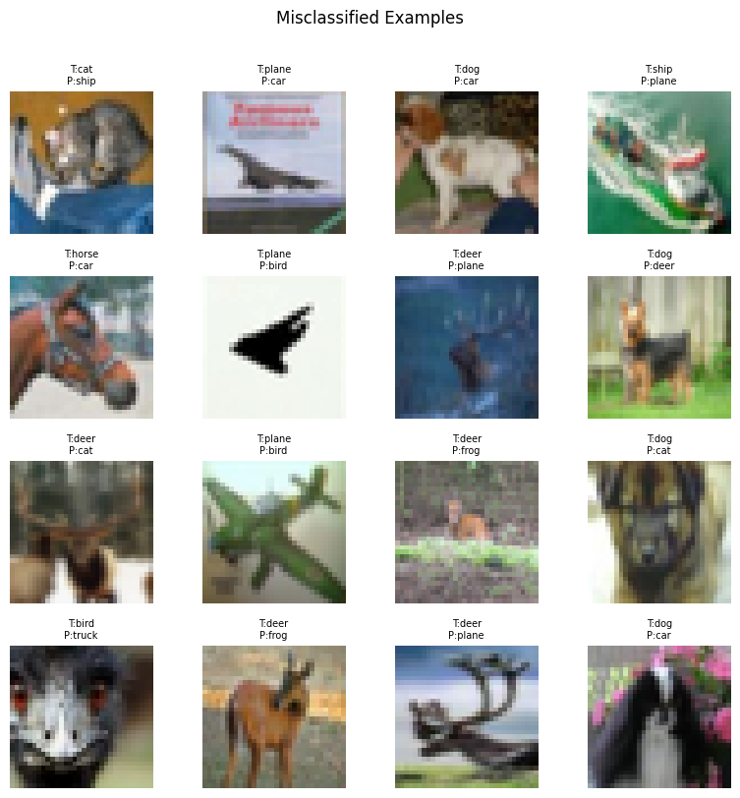

Changing scheduler from steplr to CosineAnnealingLR also realized bn was defined but not implemented correctly
Plateaued around 55% at epoch 30 stopped early

Changing weight decay to 5e^-4 and increasing hidden channels
Saw an increase in both train and val to 55% by epoch 20

Turned off Augmentation and saw an immediate improvement across both accuracies
But after around 15-20 epochs the val fell behind a lot
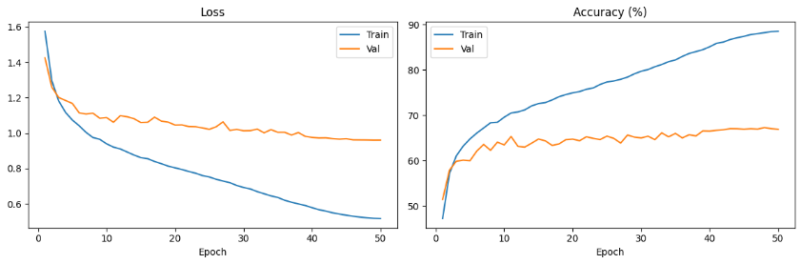
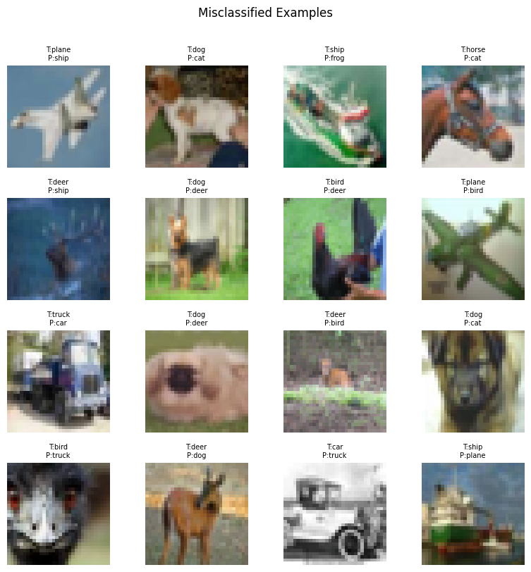
Turned augment back on but got rid of color jitter
Slight increase in accuracy sitting around 66% using this as my final iteration
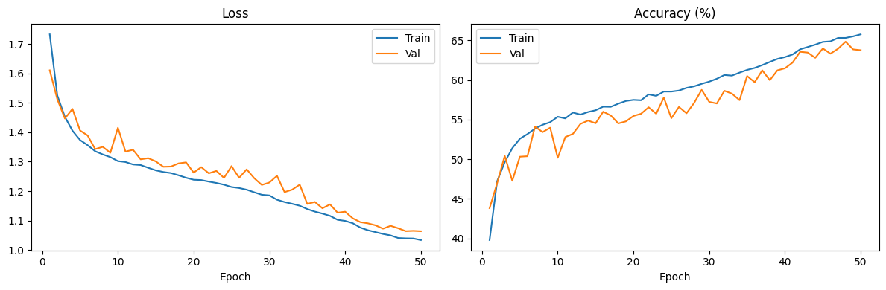
Final Test Loss: 0.9532 | Final Test Accuracy: 67.97%
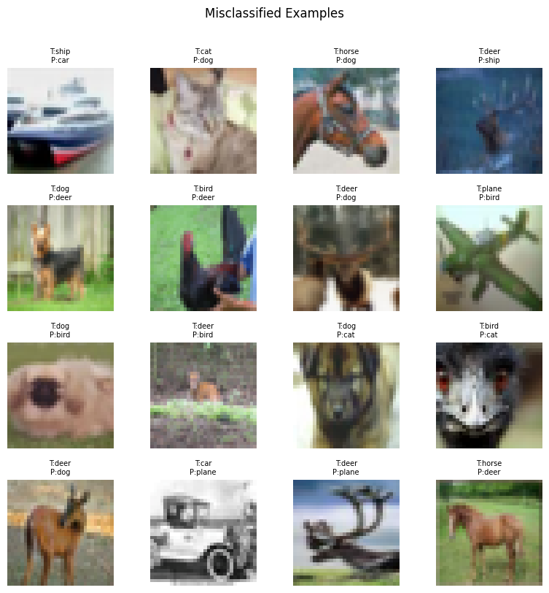
Good final test accuracy for two layer using
Lr 2e^-1 wd 5e^-4 batch size 256 sgd optimizer with basic augmentation and normalization as well as batch normalization

3 Layer CNN
Added the jitter back and kept all params the same
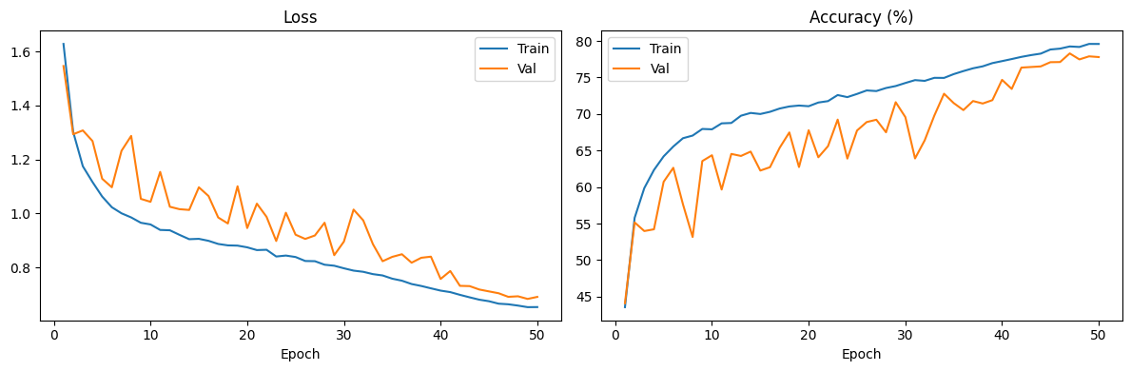
Final Test Loss: 0.6164 | Final Test Accuracy: 79.59%
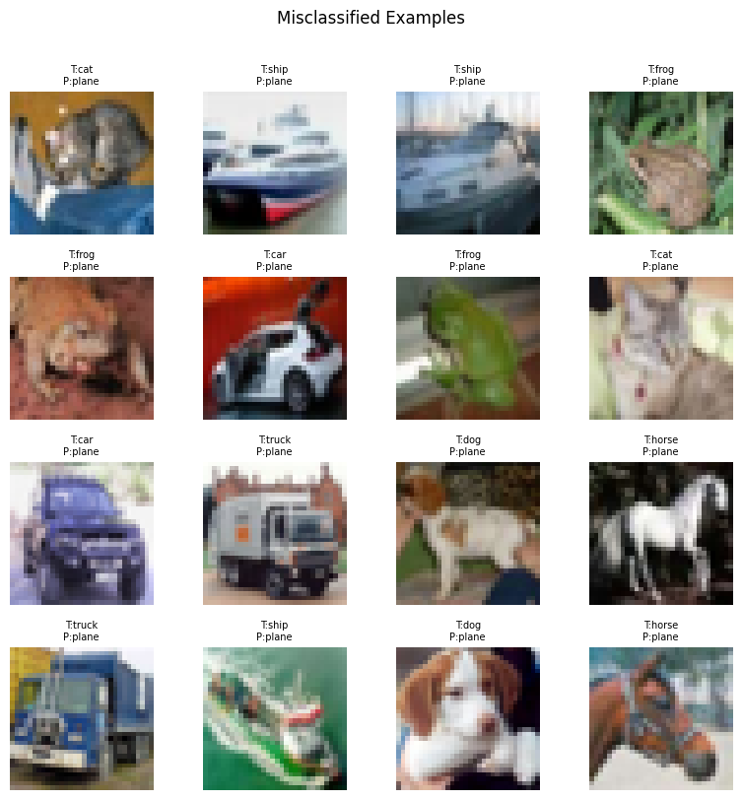
Test accuracy of 80% is really good and above what was expected
Removing the jitter on the 3 layer results in 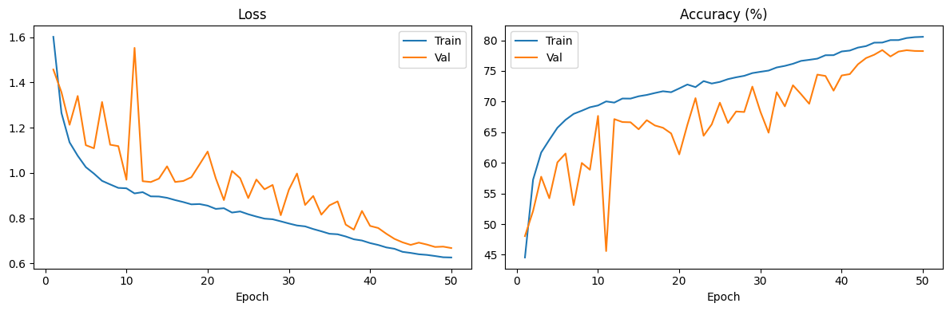
Final Test Loss: 0.6017 | Final Test Accuracy: 80.37%
but the validation has more spikes of greater depth making me think its performance is not as trustworthy

added jitter and random grayscale to the transforms increased batch size to 512
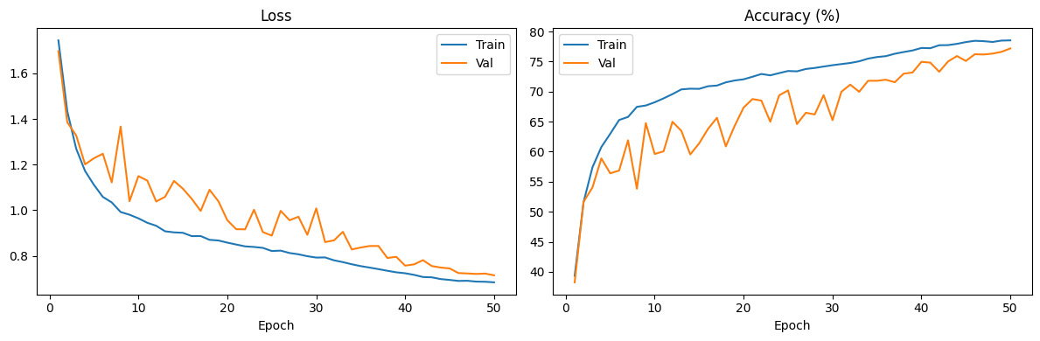
Final Test Loss: 0.6298 | Final Test Accuracy: 79.21%
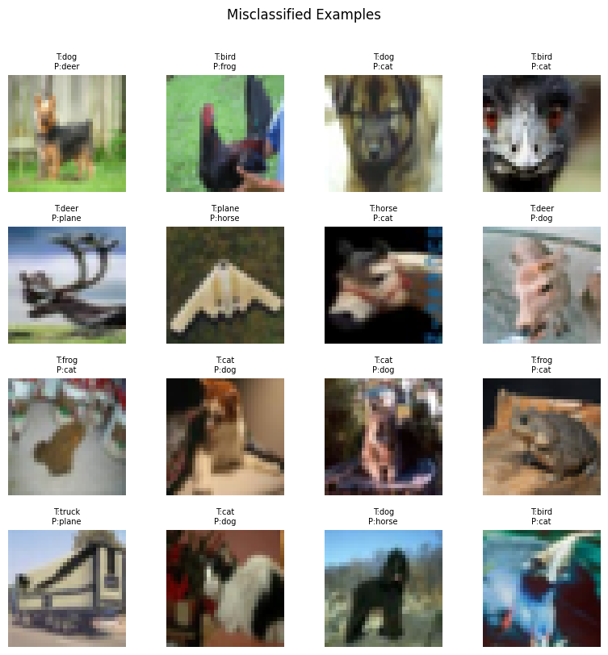
Doubled all channels
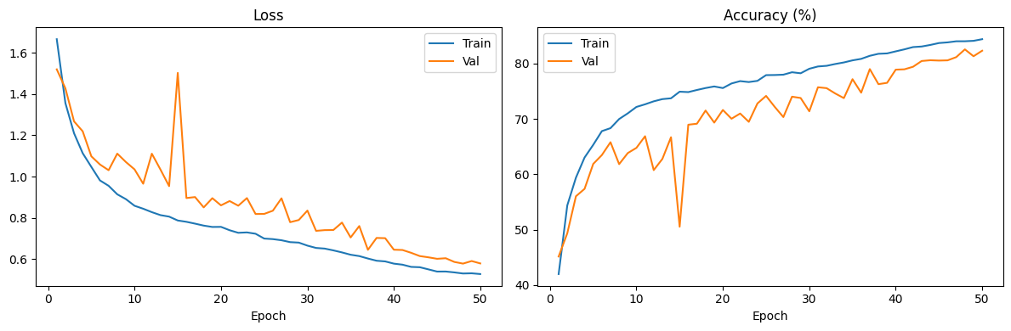Final Test Loss: 0.4964 | Final Test Accuracy: 84.01%
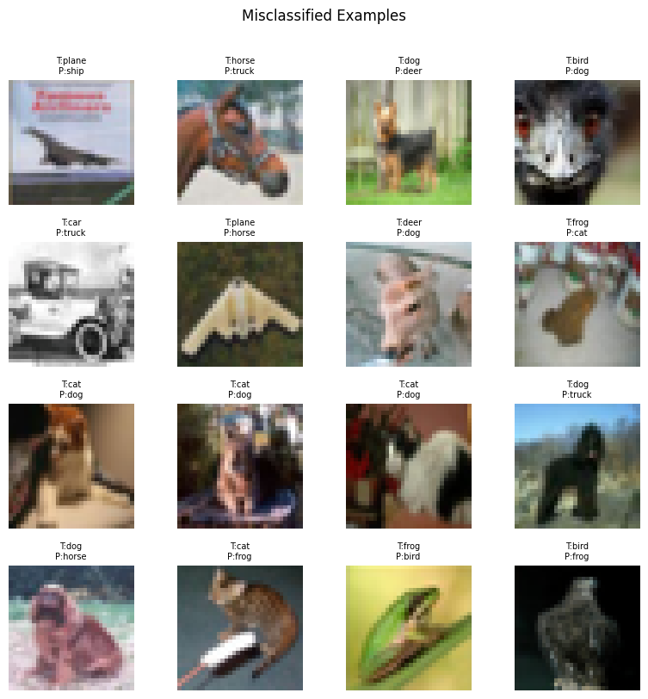

decreased weight decay to 5e^-5
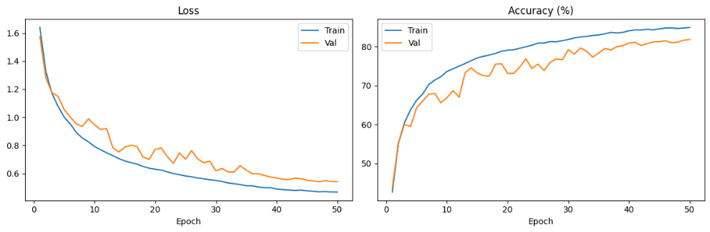
Final Test Loss: 0.4680 | Final Test Accuracy: 84.14%
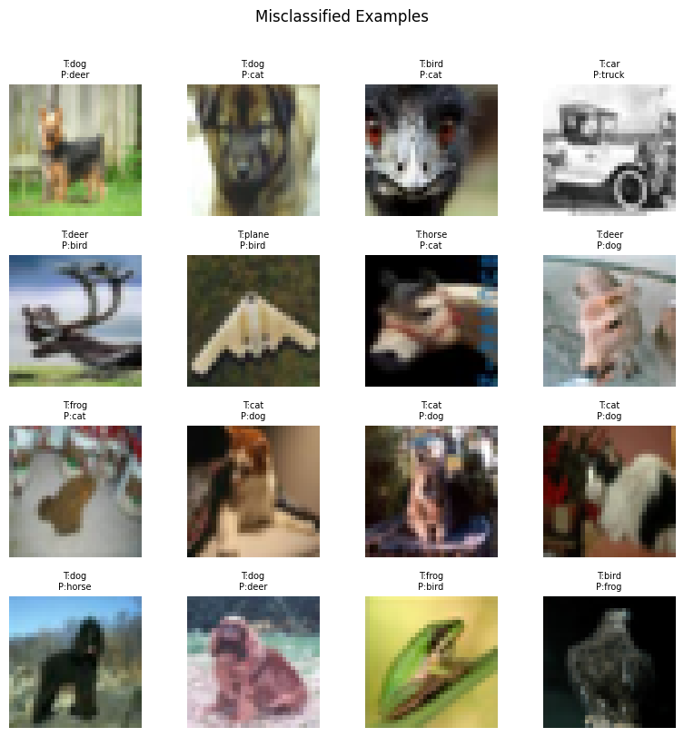
Plateaued at 84.75 on train and performed well on the test this is my final 3 layer cnn performance

Part C
Performance : the learning rate was the same across both two and three layer as well as the epochs, optimizer, normalization and batchnorm usage. The weight decay, batch size, and data augmentation changed for the three layer
Final validation accuracy for each
Two layer: 63% ish
Three layer: 81% ish

Training Dynamics
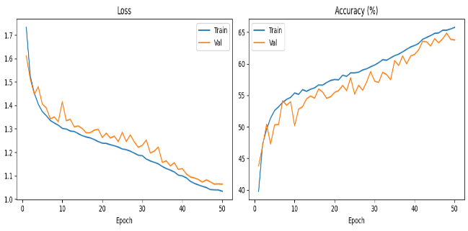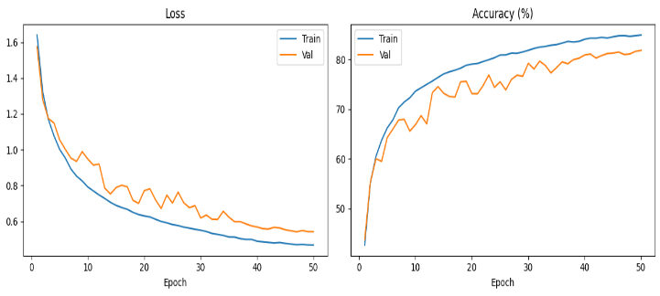

The two layer is less of an gradual curve and almost seems linear at some points, could’ve maybe benefited from more epochs but I am having issues with runtime, for the three layer the validation is not as closely correlated to the train but reaches greater heights and is more gradual.
Failure Cases

Im slightly confused how to compare these but these are from the two final test runs with the left being the two layer and the right being the three layer

